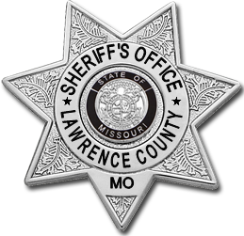
Lawrence County Sheriff’s Office
Brad DeLay, Sheriff
240 N. Main, Suite 10, Mt. Vernon, MO 65712
Ph: (417) 466-2131 Fax: (417) 471-1303

Civil Process Service Information

Case Header | Docket #
Vs

Party to be served (Include as much information as possible.)
Name, DOB, SS# | Identifiers
DOB:  SSN: | Hair: Eyes:  Hgt: Wgt:  Tats/Other:
Home address Preferred service location | Work Address Preferred service location
Address:  City:  Phone:  Best time to serve: | Place:  Address:  City:  Best time to serve:
Caution/Other info:

Requester/Return Info
Law Firm/Business:
Contact Person: Phone:

